Weight 1: 8 people (85 tests)

Simulation: 5 hidden features with 20000 trains

相關性分析:

total_y total_pre_y

total_y 1.000000 0.869462

total_pre_y 0.869462 1.000000

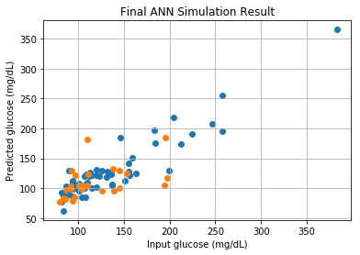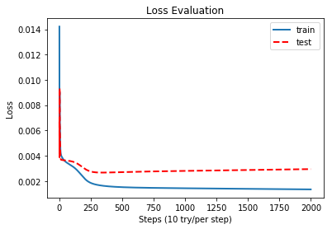

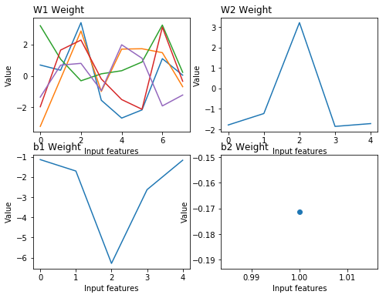

Weight 2: 8 people (85 tests)

Simulation: 5 hidden features with 20000 trains

相關性分析:

total_y total_pre_y

total_y 1.000000 0.870298

total_pre_y 0.870298 1.000000

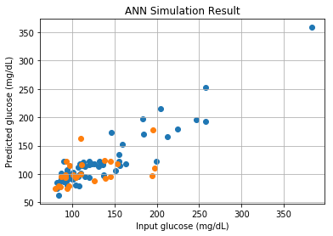 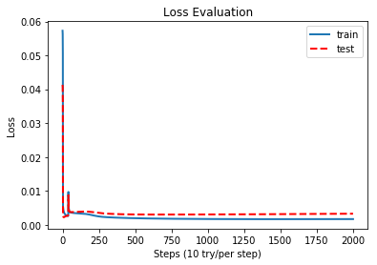

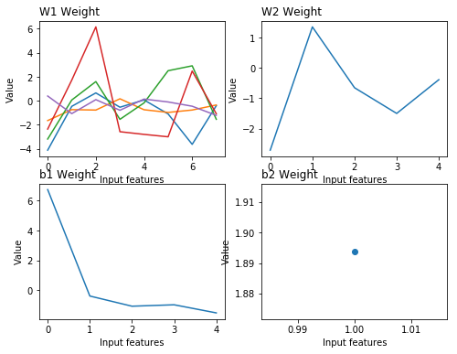

Weight 3: 8 people (85 tests)

Simulation: 5 hidden features with 20000 trains

相關性分析:

total_y total_pre_y

total_y 1.000000 0.890463

total_pre_y 0.890463 1.000000

